

SHORT-TERM PROCUREMENT PRICE FORECASTING: EVIDENCE FROM BOPP TAPE

Student’s full name: XUE QIAN
Module: Business Data Analytics Project (CNC)
Word Count: 13698 (Excluding Cover Page, table, charts, labels table of contents and References)
Seminar Leader: FRANYO, Adam BARI, Mariusz
Due Date: 2025/12/19

Dissertation submitted to International Business School For the partial fulfilment of the requirement for the degree of
MASTER OF BUSINESS DATA ANALYTICS
November 2025

DECLARATION
This thesis represents the author's independent academic research and contains no collaborative work of any kind. The author hereby grants the International Business School permission to use the entire thesis or portions thereof for non-commercial purposes (including but not limited to teaching, research, and educational activities) without compensation. Permitted uses include electronic reproduction, online dissemination, and necessary adaptations for teaching purposes.
During the writing process, certain structural designs, model methodology explanations, and limited code snippet optimizations were assisted by the ChatGPT 5.2 tool. All content generated by artificial intelligence tools has undergone rigorous academic review, critical reconstruction, and substantive revision by the author to ensure compliance with academic standards and research objectives. The core research questions, theoretical framework, data analysis, conclusion derivation, and academic perspectives presented herein were independently developed by the author, who assumes full academic responsibility for this work.
All project files, including raw data, code, and documentation, are available at: https://github.com/1490205736-ops/Thesis-Materials


XUE QIAN
17/11/2025

ACKNOWLEDGEMENTS
As this master’s dissertation is nearing completion, it is with a sense of gratitude that I would like to express my sincerest thanks to all of you who have supported and helped me in this process.
Firstly, I am very grateful to my supervisors, who not only provided valuable guidance on academic research but also helped me to continuously improve the depth and breadth of my research with their rigorous academic attitude and meticulous advice throughout the research and writing. Their patient guidance kept me moving forward on the academic path when I encountered confusion while I could not complete this dissertation without their selfless help and careful guidance.
I would also like to appreciate my classmates, who consistently spark my inspiration and broaden my perspectives through our daily academic discussions. Whenever I hit a roadblock in my studies, they patiently engage with me, offering invaluable advice and encouragement. Their companionship and support have made this challenging journey both warm and fulfilling.
In addition, the company I work as well as my colleagues have been very supportive and tolerant during my studies, enabling me to balance work and study. I would like to thank my company for providing me with a flexible schedule that allowed me to focus on my studies, and my colleagues for their understanding and collaboration, which allowed me to complete my studies despite the pressure of work and study.
Finally, I would also like to thank my family. They have given me endless support and encouragement at every stage of my study, cheering me up when I felt tired and giving me relief when I experienced stress, so that I could always keep going. Without their understanding and support, the completion of this dissertation would not have been possible.
All the above support and encouragement is the most precious motivation on my academic path, which makes me rich and growing. Thank you all.

Contents
DECLARATION ii
ACKNOWLEDGEMENTS iii
1 INTRODUCTION 1
1.1 Background 1
1.2 Research Questions and Objectives 1
1.3 Scope of the Study 2
1.4 Research Limitations 3
1.5 Dissertation’s Structure 3
2 LITERATURE REVIEW 5
2.1 Time Series Forecasting Methods 5
2.2 Machine Learning in Price Forecasting 6
2.3 Supply Chain Procurement Price Research 7
2.4 Research Gap 8
3 RESEARCH METHODS 10
3.1 Research strategy 10
3.2 Data Source and Description 11
3.3 Data Preprocessing 12
3.4 Feature Engineering 13
3.5 Model Selection 15
3.5.1 SARIMA 15
3.5.2 Prophet 16
3.5.3 Machine Learning Models 17
3.5.4 LSTM 18
3.6 Model Evaluation Metrics 18
3.7 Ethical Considerations 19
4 EXPLORATORY DATA ANALYSIS 21
4.1 Price Trend Over Time 21
4.2 Box Plot Analysis of BOPP Procurement Prices 22
4.3 Comparison Analysis of Average Purchase Prices by Supplier 25
4.4 Price Fluctuation Analysis 26
4.4.1 Moving Average Trend Analysis 26
4.4.2 Price Volatility Analysis 28
5 FORECASTING MODELS 31
5.1 Environment & Data Preparation 31
5.2 Seasonal ARIMA 32
5.3 Prophet 33
5.4 XGBoost regression model 34
5.4.1 Feature Engineering 35
5.4.2 Model Training 35
5.4.3 Comparison of Forecasts and Actuals 35
5.5 Long Short-Term Memory (LSTM) Model 36
5.5.1 Importing Libraries & Reading Data 37
5.5.2 Normalization & Construction of Supervised Learning Data 37
5.5.3 Train/Test Split & Reshaping for LSTM Input 38
6 MODEL EVALUATION AND RESULT ANALYSIS 38
6.1 Evaluation Metrics 38
6.2 Quantitative Model Performance 39
6.3 Model-Specific Performance Analysis 40
6.3.1 SARIMA 40
6.3.2 Prophet 40
6.3.3 XGBoost 41
6.3.4 LSTM 41
6.4 Best Model Selection 42
6.5 Managerial Implications of Model Performance 42
7 PRICE FORECAST FOR THE NEXT 3 MONTHS 43
7.1 Forecasting Setup 43
7.2 Forecast Results and Trend Interpretation 44
7.3 Forecast Uncertainty and Confidence Intervals 44
7.4 Implications for Short-Term Procurement Planning 45
7.5 Summary of Forecast Findings 45
8 BUSINESS INSIGHTS AND RECOMMENDATION 45
8.1 Summary of Forecast Findings 45
8.1.1 Price Volatility Remains High at the Daily Level 45
8.1.2 Short-Term Trend Is Stable with a Mild Upward Bias 46
8.1.3 Forecast Uncertainty Is Material and Should Be Explicitly Managed 46
8.2 Procurement Strategy Recommendations 46
8.2.1 Adopt Early but Phased Purchasing Within the Quarter 46
8.2.2 Use Forecast Bands as a Negotiation Reference with Suppliers 46
8.2.3 Avoid Long-Term Fixed Commitments Under High Price Uncertainty 47
8.3 Operational Recommendations 47
8.3.1 Implement a Rolling Forecast Mechanism 47
8.3.2 Develop a Price Monitoring Dashboard 47
8.4 Strategic Value of Predictive Analytics for Procurement 47
8.5 Summary 48
9 LIMITATIONS 48
9.1 Data Scope and External Validity 48
9.2 Omission of Supplier Competition and Bargaining Dynamics 48
9.3 Exclusion of Macroeconomic and Policy Variables 48
9.4 Structural Change and Model Assumptions 49
9.5 Summary of Limitations 49
10 FUTURE WORK 49
10.1 Expansion of Data Sources and Feature Scope 49
10.2 Advanced and Hybrid Modelling Approaches 50
10.3 Operationalisation and Decision-Support Integration 50
10.4 Summary of Future Work 50
11 CONCLUSION 50
11.1 Summary of Findings 51
11.2 Implications for Procurement Decision-Making 51
11.3 Contribution and Final Remarks 51
REFERENCE 52

1 INTRODUCTION

1.1 Background
In recent years, global supply chains have faced growing instability, driven by fluctuations in raw material availability, shifts in market demand, and persistent logistics disruptions. Against this backdrop, procurement costs for essential packaging materials—such as widely used BOPP tape—have become a critical factor influencing operational efficiency and profitability. Even minor price fluctuations, when accumulated over large-scale and long-term operations, can lead to substantial cost variances.
In the Chinese market, BOPP tape pricing is shaped by multiple factors, including crude oil prices, polypropylene supply, seasonal demand patterns, supplier pricing strategies, and broader macroeconomic conditions. As companies increasingly turn to data-driven approaches for procurement planning and risk management, the ability to forecast future purchase prices is emerging as a key competitive advantage in supply chain management. Accurate price predictions not only help procurement managers identify optimal purchasing timing but also strengthen their position in contract negotiations, inventory planning, and budget allocation—thereby enhancing overall supply chain resilience.
Amid growing data availability and advances in analytical techniques, enterprises are now better equipped to leverage tools such as time series analysis and machine learning to anticipate price trends for commodities and raw materials. In this context, developing a dedicated price forecasting model for BOPP tape carries both practical and strategic significance.

1.2 Research Questions and Objectives
Accurate forecasting of procurement prices is crucial for corporate cost control. However, in practice, many enterprises still rely on simplistic extrapolations based on historical averages or managerial subjective experience. Such methods struggle to effectively capture the complex trends, seasonality, and nonlinear characteristics inherent in market data, leading to insufficient predictive accuracy and ultimately compromising the scientific rigor of procurement decisions. To address this challenge and promote the application of data-driven decision-making in supply chain management, this study focuses on the following core research question:
How can a high accuracy forecasting model be developed based on historical procurement data to achieve reliable predictions of BOPP tape procurement prices for the next three months?
To answer this question, this study establishes the following specific research objectives:
- Conduct an in-depth analysis of historical procurement data to systematically identify the inherent patterns, seasonal characteristics, and key driving factors of price fluctuations.
- Construct and compare multiple forecasting models (including SARIMA, Prophet, and several machine learning models), evaluating their performance in short-term price prediction tasks.
- Determine and validate the optimal forecasting model and use it to generate point forecasts and interval forecasts for prices over the next three months.
- Integrate the model predictions with practical business scenarios to provide specific, actionable managerial recommendations for optimizing procurement strategies and supplier management.

1.3 Scope of the Study
This study is based on authentic BOPP tape procurement records provided by a new energy manufacturing enterprise in China. To protect business confidentiality, all sensitive information pertaining to the company and its suppliers has been anonymized. The data fields utilized in the research include procurement date, product material specifications, supplier (represented by codes), order quantity, and unit price.
The specific scope of the study is defined as follows:
Data Scope: Three years of procurement records from the company.
Product Scope: BOPP (Biaxially Oriented Polypropylene) tape.
Forecast Horizon: Short-term price forecasting for the next three months.
Modeling Approach: A comparative study of forecasting models, including SARIMA, Prophet, LSTM and several machine learning models.

1.4 Research Limitations
The predictive outcomes of this study should be interpreted within the following constraints:
First, the research data originates from a single enterprise, whose procurement behaviors and market characteristics may not fully represent the broader industry norms, thereby limiting the external applicability of the findings to some extent.
Second, the model construction primarily focuses on uncovering internal patterns within historical price sequences and does not explicitly incorporate competitive dynamics among suppliers or their bargaining mechanisms. These critical market elements remain outside the modeling framework.
Furthermore, due to limitations in data availability and completeness, external macroeconomic and policy variables—such as crude oil prices and industrial policies—have not been included as input features in the model. This omission may reduce the model's ability to explain price fluctuations caused by exogenous shocks.
Finally, the time-series methods employed inherently rely on the continuity of historical trends. As such, they possess inherent limitations in detecting and forecasting structural changes triggered by sudden events, such as emergency policy adjustments or supply chain disruptions.
Despite these limitations, this study represents a meaningful attempt to advance methodology in data-driven procurement forecasting and provides an empirical foundation for developing more comprehensive predictive systems in commercial practice.

1.5 Dissertation’s Structure
This report consists of nine chapters, with each chapter closely aligned with the research questions and objectives. The specific organization is as follows:
Chapter 1: Introduction– Systematically elaborates on the research background, core issues, scope definition, and limitations, clarifies the research objectives and value, and establishes the logical foundation for subsequent analysis.
Chapter 2: Literature Review – Reviews time series forecasting, the application of machine learning in price prediction, and procurement management-related studies, identifies gaps in existing research, and defines the theoretical positioning and innovative contribution of this study.
Chapter 3: Research Methodology – Details the data sources, preprocessing procedures, feature engineering strategies, and rationale for model selection, while specifying model evaluation criteria and research ethics considerations.
Chapter 4: Exploratory Data Analysis – Utilizes statistical descriptions, trend decomposition, and relevant visualization techniques to deeply uncover the fluctuation characteristics and inherent patterns in historical price data.
Chapter 5: Model Development – Step-by-step explanation of the theoretical basis, parameter configuration, training processes, and optimization methods for the SARIMA, Prophet, and machine learning models.
Chapter 6: Model Evaluation and Comparison – Employs multi-dimensional evaluation metrics to quantitatively compare the predictive performance of different models and analyzes their applicability in conjunction with business scenarios.
Chapter 7: Price Forecast for the Next 3 Months – Presents the three-month price forecast based on the optimal model, including point forecasts, interval estimates, and uncertainty analysis.
Chapter 8: Business Insights and Recommendations – Translates the forecasting results into specific management measures regarding procurement strategy, inventory optimization, and supplier collaboration.
Chapter 9: limitation - Identifies the key constraints of the study, including data scope restrictions, the exclusion of supplier competition and macroeconomic factors, and the inherent limitations of time-series models in capturing structural breaks, thereby clarifying the boundaries within which the research findings should be interpreted.
Chapter 10: Future Work – Summarizes the research findings and limitations, and proposes potential directions for future research.
Chapter 11：Conclusion - Summarizes the research objectives, methodological approach, and main empirical findings, evaluates the effectiveness of data-driven price forecasting for procurement decision-making, and highlights the study’s practical contributions while outlining its implications for future analytical and managerial development.

2 LITERATURE REVIEW
This chapter systematically reviews theoretical and empirical studies relevant to this research, with a particular focus on time series forecasting techniques, machine learning applications in price prediction, and supply chain management and procurement pricing. Through a critical synthesis of existing literature, it identifies current research gaps and limitations, thereby establishing the theoretical contribution and innovative direction of this study.

2.1 Time Series Forecasting Methods
Time series forecasting methods are widely employed in economics, finance, and supply chain management to predict time-dependent variables such as commodity prices, demand levels, or inventory metrics. Among traditional statistical models, ARIMA (Autoregressive Integrated Moving Average), introduced by Box and Jenkins (1970), represents one of the most influential approaches. This model captures underlying trends and noise structures in data through autoregressive, differencing, and moving average components, demonstrating strong performance in stationary or weakly trending sequences. However, since ARIMA does not inherently handle seasonal variations, it is often extended to SARIMA (Seasonal ARIMA) in practical applications to account for periodic fluctuations (Chatfield, 2016).
In recent years, the Prophet model, developed by Facebook (Taylor & Letham, 2017), has gained popularity in business forecasting. Built on an additive modeling framework, Prophet decomposes time series into trend, seasonal, and holiday effect components, offering high interpretability and robustness. Research indicates that Prophet performs particularly well with business datasets characterized by missing values, shifting patterns, or trend breaks (Ghazali et al., 2020), making it often more aligned with real-world enterprise data characteristics than conventional statistical models.
Beyond statistical approaches, deep learning architectures such as LSTM (Long Short-Term Memory) have shown remarkable performance in price forecasting. Capable of capturing long-term dependencies and nonlinear relationships, LSTM is especially suitable for data with complex trends or weak seasonal patterns (Hochreiter & Schmidhuber, 1997). Multiple studies have demonstrated its superiority over traditional models in predicting energy prices, agricultural product prices, and chemical raw material costs (Sagheer & Kotb, 2019; Shahid et al., 2021). Nevertheless, the substantial data requirements and computational resources of deep learning pose certain limitations in practical enterprise settings.
In summary, while statistical models remain effective for stable linear trends and clear seasonal patterns, and deep learning excels in modeling complex nonlinear relationships, Prophet offers a balanced solution with its flexibility and user-friendliness, establishing itself as a valuable tool in real-world business forecasting applications.

2.2 Machine Learning in Price Forecasting
With the increasing availability of data resources, machine learning technologies have gained growing importance in the field of price forecasting. These methods demonstrate significant advantages in capturing nonlinear relationships, automatically identifying key predictors, and processing high-dimensional datasets. Among various machine learning algorithms, tree-based ensemble methods such as Random Forest (Breiman, 2001) and XGBoost (Chen & Guestrin, 2016) have become mainstream tools in economic and commodity price prediction.
Empirical studies indicate that in price forecasting tasks for bulk commodities including plastic raw materials, steel, and chemical products, machine learning models generally achieve higher prediction accuracy compared to traditional linear models (Feng et al., 2019). Taking XGBoost as an example, this algorithm not only effectively handles feature noise but also accurately captures complex interaction effects among multiple predictive variables, thereby demonstrating superior stability and predictive accuracy in material price forecasting.
However, the application of machine learning methods in price forecasting still faces several challenges:
First, these approaches lack explicit modelling of intrinsic dependencies in time series data, typically requiring feature engineering techniques such as lagged variables or sliding windows to incorporate temporal dimension information;
Second, the black-box nature of model decision processes leads to insufficient interpretability, which somewhat hinders business teams' understanding and trust in forecasting results;
Furthermore, these methods heavily rely on data quality and feature engineering, necessitating specialized data preprocessing and feature selection procedures.
Given these characteristics, in current price forecasting research, machine learning methods primarily serve as valuable complements to traditional time series analysis techniques, enhancing overall prediction performance through model comparison and ensemble strategies.

2.3 Supply Chain Procurement Price Research
Price forecasting holds significant strategic value in supply chain management. As Christopher (2016) demonstrated, precise short-term price predictions enable companies to enhance procurement planning, optimize safety inventory levels, and strengthen negotiation positions with suppliers. Supporting this view, research by Choi et al. (2018) identified price volatility as a major contributor to supply chain cost uncertainty, particularly in sectors dealing with packaging materials, chemical products, and energy resources.
The price of tape is closely related to the cost of upstream raw materials. For instance, the price of BOPP tape is influenced by factors such as crude oil prices, fluctuations in chemical production, and changes in national policies (Zhang & Wang, 2021). Relevant studies also indicate that demand volatility, seasonal order patterns, and supplier pricing strategies are key factors affecting procurement prices (Kaur & Singh, 2020). These findings provide a theoretical basis for feature selection in this study.
Despite these established relationships, current academic work remains predominantly focused on macro-level price forecasting in raw material markets. There exists a notable research gap concerning enterprise-level procurement price analysis for downstream packaging materials such as tape. While micro-level enterprise data offers greater relevance to actual business operations, such practical investigations remain substantially underrepresented in the scholarly literature.

2.4 Research Gap
Based on a systematic review of existing literature, this study has identified four key research gaps that collectively constitute the core innovative contributions of this research:
(1) Significant Gap in Forecasting Research for Tape Procurement Prices
While numerous studies have focused on price forecasting for bulk commodities such as crude oil and polypropylene, specialized research on BOPP tape—an important industrial packaging material—remains quite limited. Existing literature mostly treats it as a generic downstream product of polypropylene, lacking in-depth exploration of its unique price formation mechanism. As an industrial product requiring multiple processing stages, BOPP tape's pricing is influenced not only by raw material costs but also by multiple factors including processing technology, industry competition patterns, and product differentiation levels. This complex price formation mechanism has not been systematically analyzed in academic research.
(2) Severe Shortage of Empirical Research Based on Authentic Enterprise Procurement Data
Most current price forecasting studies rely on publicly available market prices or commodity futures data. While easily accessible, these data cannot fully reflect the complexities faced in actual enterprise procurement processes. Real procurement data encompasses multiple influencing factors such as supplier variations, economies of scale, long-term contract terms, and payment conditions, which collectively constitute the actual procurement costs at the enterprise level. The lack of analysis on these micro-level data limits the practical value of existing research findings in guiding specific corporate procurement decisions.
(3) Insufficient Systematic Comparative Studies of Multiple Models
Literature review reveals that existing research predominantly employs single models for price forecasting, lacking systematic comparison across different types of predictive models. While traditional time series models, modern statistical learning methods, and machine learning algorithms each have their applicable scenarios and limitations, their relative advantages and disadvantages for the specific problem of BOPP tape price forecasting have not been adequately validated. By simultaneously applying SARIMA, Prophet, and various machine learning models while conducting rigorous performance comparisons, this study aims to provide both theoretical basis and practical reference for model selection in this specific forecasting context.
(4) Inadequate Development of Forecasting Tools for Short-term Procurement Decisions
Academic research on price forecasting predominantly concentrates on medium to long-term trend analysis, while corporate procurement decisions require more precise forecasts for the next 1-3 months. This mismatch between the demand for short-term forecasting and the actual research supply makes it difficult to translate much theoretical research into practical decision-support tools for procurement. This study specifically focuses on three-month price forecasting, committed to developing practical forecasting tools that genuinely meet enterprise procurement planning needs.
Positioning of This Study's Innovation
Based on the identification of the above research gaps, this study will systematically address the voids in existing literature across three dimensions by integrating diversified analytical methods, authentic enterprise data, and business-oriented forecasting perspectives: in terms of research object, it pioneers specialized research on BOPP tape procurement prices; in research methodology, it achieves systematic comparison and validation of multiple models; in application value, it develops practical forecasting solutions oriented toward enterprise short-term procurement decisions. This comprehensive research approach possesses not only academic innovative significance but also notable practical application value.

3 RESEARCH METHODS
This chapter elaborates on the data sources, preprocessing procedures, feature engineering methods, and rationale for model selection, along with the model evaluation metrics and ethical considerations. The research methodology adheres to the principles of replicability, interpretability, and verifiability, thereby ensuring the accuracy and reliability of the predictive outcomes.

3.1 Research strategy
This study adopts a quantitative research approach, constructing a time series forecasting model based on historical pricing data for tape procurement from 2022 to 2024. The research process follows a structured analytical framework, comprising the following specific steps:
Data Collection and Organization
Procurement data for tapes from 2022 to 2024 were collected, with key variables including purchase dates, transaction prices, supplier information, material categories, and order quantities. The raw dataset encompasses multi-dimensional fields, laying a foundation for subsequent analysis.
2. Data Preprocessing
Systematic data quality issues were addressed, including handling missing values, identifying and correcting anomalous price points, standardizing date formats, and normalizing supplier and material category naming conventions. This process resulted in a consistent and reliable dataset for analysis.
3. Exploratory Data Analysis (EDA)
Descriptive statistics and data visualization techniques were employed to analyze the statistical characteristics of price distributions, identify long-term trends, seasonal fluctuations, and cyclical patterns, and preliminarily detect potential outliers and structural changes.
4. Model Construction
Three types of forecasting models suitable for time series analysis were selected for training and comparison:
Classical Statistical Models: Represented by the Seasonal Autoregressive Integrated Moving Average (SARIMA) model, capturing autocorrelation and seasonal patterns in the series.
Structured Time Series Models: The Prophet model was used to fit trends, seasonality, and holiday effects.
Machine Learning Models: Algorithms such as Random Forest and Gradient Boosting Trees were applied to explore nonlinear features and interactions.
5. Model Evaluation and Comparison
Evaluation metrics, including Root Mean Square Error (RMSE), Mean Absolute Error (MAE), and Mean Absolute Percentage Error (MAPE), were used to comprehensively compare model performance across three dimensions: predictive accuracy, robustness, and interpretability. The optimal forecasting model was selected based on these criteria.
6. Forecasting and Business Interpretation
Using the validated optimal model, procurement price forecasts for the next three months were generated. The results were interpreted in the context of business scenarios, highlighting their managerial implications, including support for procurement decisions, cost control recommendations, and supply chain risk warnings.
The research design strictly adheres to standard methodologies for time series forecasting, balancing modeling rigor with practical applicability. This approach ensures the statistical reliability of the forecasting results while emphasizing their relevance to actual business operations.

3.2 Data Source and Description
The data used in this study are sourced from the real procurement system of a manufacturing enterprise and include the following variables:
Date: The specific date of each procurement transaction.
Material Type: Various types of industrial tapes, including BOPP tape, masking tape, and duct tape;
Price: The unit procurement cost in Chinese Yuan (CNY).
Supplier: Anonymized codes representing different suppliers.
Quantity: The volume of products purchased in each transaction.
All sensitive commercial information has been anonymized to ensure no identifiable details of the company or suppliers are disclosed.
The dataset exhibits the following key characteristics:
- A complete time-series structure with precise timestamps for each record, suitable for time-series analysis and modelling;
- Significant fluctuations in procurement prices, reflecting market dynamics, seasonal demand variations, and supply chain changes;
- Potential data quality issues such as missing values, outliers, or duplicate entries, which require systematic data cleaning prior to modelling.
With its appropriate scale, comprehensive time coverage, and well-defined variables, this dataset provides a reliable foundation for time-series forecasting tasks such as procurement price prediction and supplier behaviour analysis. Predictive models built on this data can offer valuable insights for corporate procurement decision-making and cost control strategies.

3.3 Data Preprocessing
To ensure model reliability and prediction accuracy, a systematic preprocessing pipeline was implemented on the raw procurement data, with the following key steps:
（1）Date Standardization
The original date field was converted into a standardized datetime format and set as the data index to meet the input requirements of time-series models and facilitate subsequent analysis.
（2）Missing Value Handling
Missing values in continuous variables such as purchase price were filled using time-series-sensitive methods, primarily linear interpolation or forward filling.
Records with missing categorical fields (e.g., supplier names) were removed if values could not be reasonably inferred from context, ensuring data consistency.
（3）Outlier Detection and Treatment
Multiple methods were employed to collaboratively identify outliers in purchase prices:
Statistical range detection based on the Interquartile Range (IQR)
Boxplot visualization for auxiliary judgment
Z-score standardization to detect extreme deviations
Data points confirmed as entry errors or significant inaccuracies were corrected or removed based on business logic.
（4）Data Smoothing and Aggregation
To mitigate noise and maintain temporal stability given the irregular frequency of raw procurement records:
High-frequency transaction data were aggregated into daily average prices
Weekly average sequences were generated when necessary
Raw granular data were retained to accommodate different modeling needs
（5）Time-Series Data Splitting
A temporal split strategy was adopted:
Training set: the first 80% of the data by time
Test set: the remaining 20% of the data
Random splitting was strictly avoided to prevent temporal leakage, ensuring the timeliness and reliability of model evaluation.

3.4 Feature Engineering
Feature Engineering
Feature engineering aims to enhance the model's ability to capture trends, seasonality, and fluctuations. The main steps are as follows:
(1) Temporal Feature Extraction
Extract structured time features from timestamps, including:
- Year
- Month
- Week of the year
- Day of the month
- Day of the week
- Quarter end indicator
Note: Traditional time series models (e.g., SARIMA, Prophet) automatically handle seasonal components. These features are primarily intended for machine learning models.
(2) Lag Features
Construct lagged historical price values as predictors:
- 1-day lagged price (lag_1)
- 7-day lagged price (lag_7)
- 30-day lagged price (lag_30)
These features effectively capture short-term dependencies and periodic patterns in prices.
(3) Rolling Window Statistics
Calculate statistical measures via sliding windows to capture local trends and volatility:
- 7-day moving average (MA_7)
- 30-day moving average (MA_30)
- 15-day rolling standard deviation (rolling_std_15)
- Recent extreme values (recent highest/lowest prices)
(4) Categorical Variable Encoding
Apply one-hot encoding to categorical variables such as supplier and material type, converting them into numerical formats for machine learning models.
(5) Feature Normalization
Perform Z-score standardization on continuous features like price and quantity to improve training efficiency and convergence stability.

3.5 Model Selection
To ensure the accuracy of forecasting results, this study employs three categories of models for comparison:

3.5.1 SARIMA
SARIMA (Seasonal Autoregressive Integrated Moving Average) is suitable for data exhibiting seasonality and trend, with key advantages including:
- Ability to model seasonal patterns
Explicitly captures periodic seasonal fluctuations in time series data.
- Effectiveness with small datasets
Maintains robust performance with limited data samples compared to complex deep learning models.
- Strong interpretability
Model parameters have clear statistical interpretations, facilitating analysis of how different components influence the series.
Model selection is determined through the following systematic approach:
- ACF/PACF analysis
Uses Autocorrelation Function (ACF) and Partial Autocorrelation Function (PACF) plots to identify appropriate autoregressive and moving average orders.
- Information criterion optimization
Employs Akaike Information Criterion (AIC) and Bayesian Information Criterion (BIC) for model selection, balancing goodness-of-fit against model complexity.
- Automated parameter search
Utilizes tools like auto_arima for systematic exploration of parameter space, ensuring identification of globally optimal parameter combinations.
This methodology integrates statistical principles with practical efficiency, maintaining theoretical foundation while addressing real-world engineering requirements.

3.5.2 Prophet
Reasons for Selecting the Prophet Model
1. High adaptability to business time series data
- Effectively handles common real-world scenarios such as missing values and irregular sampling frequencies
- Demonstrates strong robustness to outliers without requiring complex preliminary data cleaning
2. Automated modelling capabilities
- Built-in trend decomposition components that automatically identify long-term trends, seasonality, and change points in data
- Supports multi-period seasonality modelling (yearly, weekly, daily cycles, etc.)
3. Intuitive result interpretability
- Provides clear prediction confidence intervals for assessing forecast uncertainty
- Enables independent analysis of components (trend, seasonality) through decomposable forecast results
4. Advantages for engineering practice
- Intuitive parameter settings and simplified modeling process significantly reduce technical barriers
- Supports rapid model iteration suitable for deployment in enterprise environments
Key Parameter Configuration
- Growth type: Options for linear or logistic growth patterns
- Seasonality parameters: Configures periodicity and Fourier series complexity
- Holiday effects: Incorporates specific business holidays or event impact factors
- Changepoint detection: Adjusts sensitivity to structural trend changes
This selection balances model performance with implementation costs, ensuring both prediction accuracy and meeting practical requirements for enterprise-level applications in terms of usability and interpretability.

3.5.3 Machine Learning Models
The core advantage of machine learning models lies in their ability to effectively integrate multidimensional features and capture complex nonlinear relationships between variables. Compared with traditional statistical methods, machine learning algorithms are better suited for processing high-dimensional, multi-source industrial data, thereby providing more powerful modeling capabilities for price prediction.
Model Selection and Characteristics
This study selects two representative ensemble learning models for comparative analysis:
1. Random Forest
- Ensemble architecture based on multiple decision trees, enhancing robustness through voting mechanisms
- Natural resistance to data noise and outliers
- Built-in feature importance evaluation enhances model interpretability
2. XGBoost
- Utilizes gradient boosting framework with exceptional prediction accuracy and computational efficiency
- Demonstrates excellent generalization capability in time series forecasting tasks
- Supports regularization terms to effectively control model complexity
Feature Engineering Architecture
To fully leverage the advantages of machine learning models, we constructed a multidimensional feature input system:
- Temporal Dynamic Features: Lagged prices, rolling statistics (moving averages, standard deviations, etc.)
- Temporal Semantic Features: Date-based cyclical encodings (season, month, week, etc.)
- Business Entity Features: Categorical variables including supplier codes and material categories
- Interaction Features: Combined features between key variables

Through systematic feature engineering and model optimization, we have developed a machine learning solution that balances prediction accuracy with business interpretability, providing reliable technical support for procurement price forecasting.

3.5.4 LSTM
Long Short-Term Memory (LSTM) is a specialised recurrent neural network architecture designed for sequential data analysis and long-term dependency modelling. By incorporating memory cells controlled by input, forget, and output gates, LSTM enables selective information retention across time steps, making it widely used in time series forecasting applications.
Model Characteristics
The main characteristics of the LSTM model include:
- Memory-based architecture, allowing learning of long-range temporal dependencies
- Nonlinear modeling capability, enabling representation of complex relationships between historical prices and future values
- Independence from explicit seasonal assumptions, making it applicable to datasets with irregular or weak seasonal patterns
Input Structure and Role in This Study
A sliding window approach with a fixed look-back period is adopted to construct sequential input samples from historical price data, with Min–Max normalization applied to improve training stability.
In this study, LSTM serves as a benchmark deep learning model, used to assess whether increased model complexity can improve short-term price forecasting performance compared with statistical and machine learning approaches in an enterprise procurement context.

3.6 Model Evaluation Metrics
Model Evaluation Metrics
To systematically evaluate the predictive performance of each model, this study employs the following four core evaluation metrics:
(1) Root Mean Square Error (RMSE)
- Highly sensitive to larger prediction errors
- Effectively reflects prediction stability and extreme deviations
(2) Mean Absolute Error (MAE)
- Intuitively represents the average absolute deviation between predicted and actual values
- Provides good business interpretability
(3) Mean Absolute Percentage Error (MAPE)
- Measures relative error levels, facilitating cross-magnitude prediction accuracy comparisons
- Note: Requires attention to its sensitivity limitation with zero or near-zero values
(4) Coefficient of Determination (R²)
- Primarily used to evaluate machine learning models' explanatory power for target variable fluctuations
- Reflects model goodness-of-fit
All compared models will be evaluated under identical dataset partitioning and preprocessing conditions to ensure fairness in comparison benchmarks and reproducibility of results. Through comprehensive consideration of multi-dimensional metrics, this study aims to fully assess the accuracy and practicality of each model in the procurement price prediction task.

3.7 Ethical Considerations
Ethical Compliance and Data Governance in This Study
This research strictly adheres to data security and research ethics standards, implementing the following principles throughout the entire process of data processing, model development, and results management:
1. Data Privacy and Security Protection
Comprehensive Anonymization: Irreversible desensitization of sensitive information including enterprise identifiers, supplier names, and transaction codes in the dataset
Minimal Data Usage: Retention of only essential feature fields required for modelling, with deletion of potentially sensitive information unrelated to prediction targets
Encrypted Storage and Transmission: All data encrypted using AES-256 standards to prevent unauthorized access to original information
2. Restricted Usage and Access Control
Internal Research Exclusive: All data is used solely for this academic research project, prohibiting any commercial use or third-party sharing
Tiered Authorization System: Implementation of a graded data access permission system, with core original data accessible only to principal project investigators
3. Model Interpretability and Reliability
Full Process Reproducibility: Complete documentation of data preprocessing, feature engineering, and model training parameters to ensure fully reproducible experimental results
Decision Transparency: Application of interpretability techniques including SHAP and LIME to analyse model prediction logic, avoiding business risks associated with black-box decision-making
Validation: Multi-dimensional evaluation metrics and business scenario testing to ensure model outputs align with actual business logic
4. Academic Compliance Assurance
• All code and documentation stored in private GitHub repositories according to academic institution requirements
• Strict access permissions limited to dissertation committee members and supervising instructors
• Repository contents include complete technical documentation and data preprocessing instructions to ensure transparent and standardized review processes
Through establishing a comprehensive data governance framework and ethics review mechanism, this study provides a rigorous and reliable academic practice example for procurement price prediction research while ensuring commercial data security protection.

4 EXPLORATORY DATA ANALYSIS
This chapter conducts an exploratory analysis of BOPP tape procurement prices from January 2022 to December 2024, aiming to identify trends, distribution characteristics, supplier variations, and potential fluctuation patterns, thereby establishing fundamental insights for subsequent predictive modelling.

4.1 Price Trend Over Time

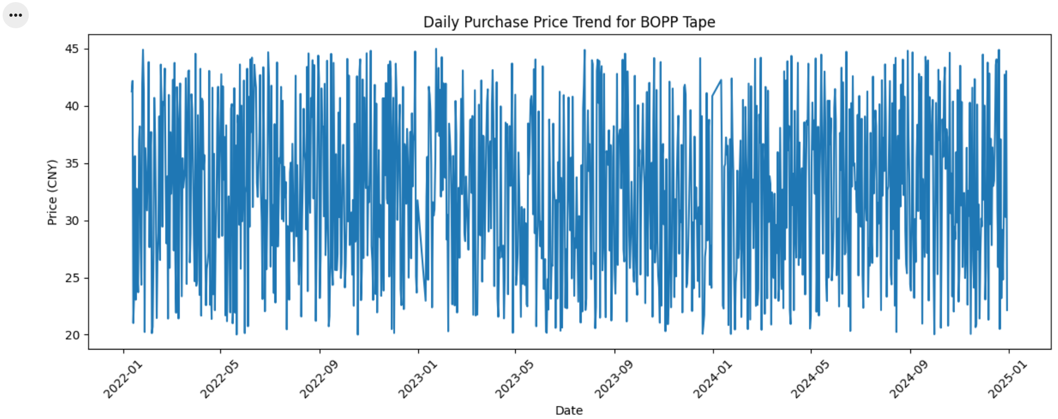
Figure 4.1 Daily Purchase Price Trend for BOPP Tape
The Daily Purchase Price Trend for BOPP Tape reveals distinct characteristics in procurement prices from January 2022 to the end of 2024. The data exhibits significant high-frequency volatility, yet remains relatively stable within a consolidated range. Prices predominantly fluctuate between 20 CNY and 45 CNY, with no extreme price jumps, indicating that while influenced by market dynamics, the procurement price of this raw material has not experienced structural disruptions or sudden shocks.
The dense and frequent fluctuations in the daily price curve suggest that procurement prices are primarily driven by short-term factors such as supplier pricing strategies, shifts in short-term market supply and demand, and variations in order volumes. As a result, the data demonstrates the following patterns:
- Pronounced Short-Term Fluctuation
Continuous oscillations without clear seasonal cycles or long-term trends imply:
- Frequent changes in market supply and demand.
- Frequent variations mainly due to differing pricing strategies among suppliers (e.g., Supplier X/Y/Z);
- Price negotiation differences across procurement batches.
- Absence of simple mean-reverting characteristics.
- No Strong Long-Term Trend
Although minor upward or downward movements occurred in certain periods (e.g., mid-2023), the fluctuation center consistently remained within the 30–40 CNY range, reflecting overall price stability over the two-year span.
- Healthy Volatility
Such frequent short-cycle fluctuations are commonplace in bulk raw material sectors (such as the packaging materials industry), indicating that procurement departments are not facing supply chain disruptions or abnormal price pressures, but rather operating within the normal range of market negotiations.
Conclusion: Implications for Modelling
These trend characteristics have direct implications for subsequent modeling:
Simple linear trend models (e.g., linear regression) are unsuitable;
Models capable of handling high-frequency noise and short-term fluctuations (e.g., SARIMA, Prophet, XGBoost) are required.
Future price forecasting should prioritize short-term predictions rather than long-term structural changes;
The data’s stability makes it well-suited for 1–3 month forecasting windows.

4.2 Box Plot Analysis of BOPP Procurement Prices
The box plot visually presents the distribution pattern, dispersion degree, and outlier status of BOPP tape procurement prices. By analysing the positional relationship between the median and quartiles, the range of the box and whiskers, as well as the distribution of discrete points, it systematically reveals the central tendency, fluctuation amplitude, and potential anomalies in the price data. This provides key visual evidence for determining price distribution characteristics, identifying extreme quotations, and performing data cleaning prior to modelling.
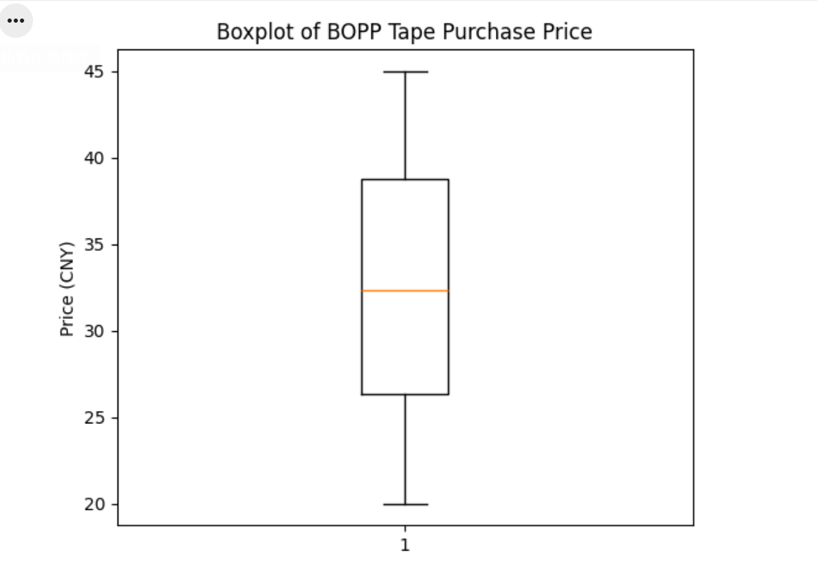
Figure 4.2 Box of BOPP tape procurement prices
The image displays a box plot of BOPP tape procurement prices, used to assess the price distribution pattern, dispersion degree, and the presence of any outliers.
- Clear Price Distribution Characteristics
From the box plot, the following can be observed:
The median is approximately 32 CNY, indicating that many procurement prices are clustered around 32 CNY.
The upper quartile is around 38–40 CNY, showing that 25% of procurement prices exceed 38 CNY.
The lower quartile is approximately 26–27 CNY, meaning the lowest 25% of procurement prices are below about 27 CNY.
Overall, the area around 32 CNY represents a highly typical procurement price level.
- High Price Dispersion (Significant Volatility)
The tall box in the plot indicates a wide fluctuation range in procurement prices:
The price range spans approximately from 20 CNY to 45 CNY.
The upper and lower whiskers show a large price fluctuation span, consistent with the high-frequency volatility observed in the trend chart.
This implies:
Enterprises experience considerable price variations across different dates and suppliers, making cost control reliant on accurate forecasting and supplier strategies.
- No Significant Outliers
The absence of isolated scatter points in the box plot indicates:
Data fluctuations are within a normal range.
There are no extreme prices, suggesting stable data sources and good data quality.
No additional outlier removal is required for subsequent model training.
- Price Structure Suggests Influence of Supply Chain Strategies
Based on the box plot, it can be inferred:
The low-price range (20–26 CNY) may stem from specific suppliers or promotional batches.
The high-price range (38–45 CNY) could be due to raw material price increases during specific periods or high-quality batches.
The stable median indicates no trend shift in the overall price structure, with significant short-term fluctuations but relative long-term stability.
This is crucial for forecasting tasks:
Models such as SARIMA and Prophet (capturing trend and seasonality) or XGBoost and Random Forest (leveraging multiple features to capture fluctuations) are suitable.
Summary of Box Plot Analysis
Key conclusions based on the box plot:
The price median remains stable at around 32 CNY, indicating relative stability in the overall price level.
The large price fluctuation range (20–45 CNY) reflects significant influence from market or supply chain factors.
The absence of outliers indicates high data quality, which is beneficial for model training.
Prices exhibit short-term fluctuations and are influenced by multi-supplier variations, requiring forecasting models to account for both trend and volatility components.

4.3 Comparison Analysis of Average Purchase Prices by Supplier
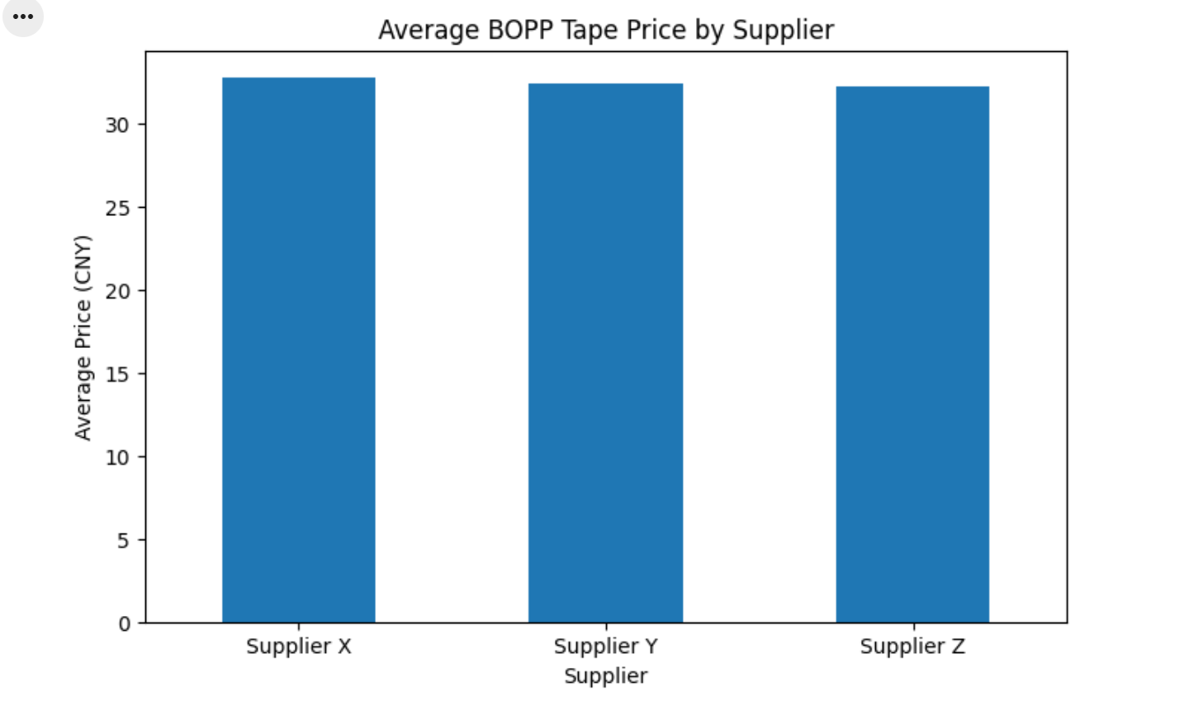
Figure 4.3 Average Purchase Prices by Supplier
The chart reveals that the average procurement prices of BOPP tape from the three main suppliers (Supplier X, Supplier Y, and Supplier Z) are highly consistent, all falling within the range of 32–33 CNY. This indicates relative stability in the overall market price, with no significant price advantage observed among different suppliers.
(1) Supplier X
The average price of Supplier X is slightly higher than that of Supplier Y but remains largely aligned with Supplier Z. This suggests that Supplier X’s pricing is close to the market average, without showing clear premium characteristics.
(2) Supplier Y
Supplier Y has the lowest average procurement price among the three, closest to 32 CNY. However, the difference is minimal (<0.3 CNY), indicating only a limited price advantage and positioning within a normal competitive price range.
(3) Supplier Z
Supplier Z’s average price is slightly higher than Supplier Y’s but overall remains highly similar to both Suppliers X and Y. Its price fluctuations are consistent with those of the other suppliers, further validating the price stability of BOPP tape as a bulk commodity in the market.

4.4 Price Fluctuation Analysis
Through an in-depth analysis of BOPP tape procurement prices using price volatility and moving averages (MA), we systematically reveal dynamic price patterns by constructing time-series features. This approach provides more interpretable structured inputs for subsequent predictive models compared to earlier static visualization methods based solely on raw procurement prices.

4.4.1 Moving Average Trend Analysis
The chart displays the daily purchase price of BOPP tape (blue) along with its 7-day moving average (orange) and 30-day moving average (green).
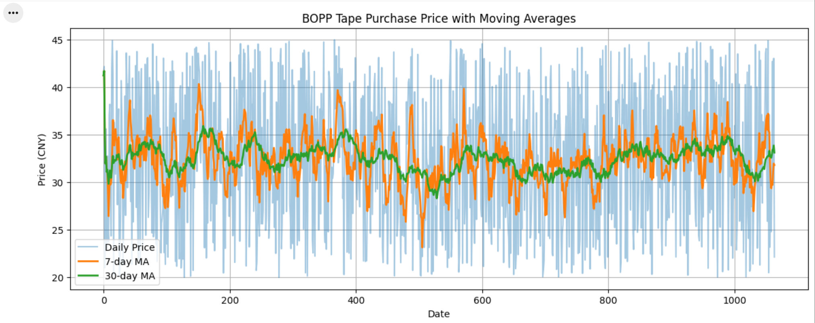
Figure 4.4.1 BOPP tape purchase price with moving average
From the image, we can draw the following conclusions:
- Daily price fluctuations are significant, showing strong noise characteristics
The blue raw price curve exhibits noticeable up-and-down fluctuations, with few periods of continuous stability. This indicates that:
The raw price is strongly affected by market supply and demand, raw material cost changes, supplier negotiation dynamics, and order volume variations.
There is substantial short-term noise, making it difficult to identify meaningful trends from daily data.
Applying moving averages to smooth the price series is therefore necessary and justified.
- The 7-day moving average (short-term trend) captures rapid price changes
The 7-day MA (orange line) is less volatile than the raw data but still shows clear short-term upward and downward trend patterns. This suggests that:
The 7-day MA is suitable for reflecting week-level price movements.
Certain time intervals show brief price increases or declines, indicating local trend behavior.
This demonstrates that short-term data still contain structural patterns, rather than being purely random noise.
- The 30-day moving average (long-term trend) shows overall price stability
The 30-day MA (green line) is significantly smoother and presents:
- Weak but consistent periodic fluctuations;
- An overall price level fluctuating around 30–33 CNY;
- No strong or persistent upward or downward trend.
This implies that:
- The long-term price trend is relatively stable.
- The supply–demand structure of BOPP tape remains balanced over time.
- Future price movements may exhibit mean-reversion behavior, making models such as SARIMA well-suited for long-term forecasting.
- The relationship between short-term and long-term moving averages provides additional signals
- When the 7-day MA rises significantly above the 30-day MA, it indicates short-term price pressure or constrained supply.
- When the 7-day MA falls below the 30-day MA, it suggests short-term weakening of prices.
- The two MAs remain close over longer periods, indicating no long-term trend of continuous growth or decline.
This offers valuable insights for forecasting model selection:
- Short-term fluctuations are substantial → models like Prophet or XGBoost are effective for capturing quick movements.
- Long-term stability → SARIMA is appropriate for modeling the smoothed long-term trend.

4.4.2 Price Volatility Analysis
To accurately quantify the fluctuation characteristics of BOPP tape procurement prices, this study employs daily returns and rolling volatility as core measurement indicators. This methodology captures short-term market volatility intensity by calculating percentage price changes between adjacent periods. Furthermore, by statistically analyzing volatility through rolling time windows, it identifies the dynamic evolution of price uncertainty across different periods, providing structured inputs for subsequent risk modelling and forecasting.
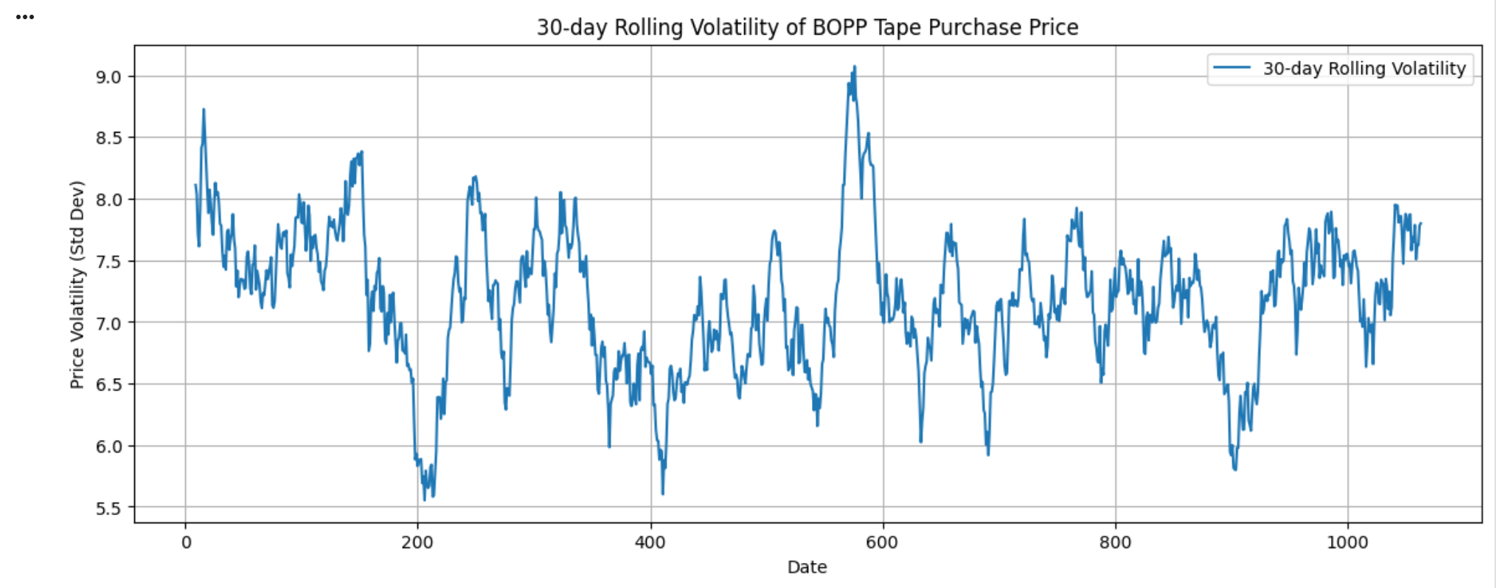
Figure 4.4.2 30-day rolling standard deviation of BOPP tape
From the chart, it can be observed that the 30-day rolling standard deviation of BOPP tape procurement prices shows periodic fluctuations throughout the sample period but remains within a range of approximately 5.5 to 9.0 CNY. Based on this volatility trend, the following conclusions can be drawn:
- Overall volatility is moderately low, indicating relatively stable market prices.
The volatility curve in the chart remains within a narrow range overall, with no extreme spikes or crashes, suggesting:
BOPP tape procurement prices have experienced mild long-term fluctuations.
Market supply and demand are generally balanced.
Price fluctuations are more likely driven by short-term factors rather than long-term structural risks.
This further confirms the observation from the moving average trend analysis:
Long-term price movements are stable, with no sustained upward or downward trend.
- Volatility exhibits distinct periodic highs and lows
As visible in the chart, volatility shows periodic peaks (around days 200, 400, 600, 800, 1000, for instance), possibly reflecting:
Seasonal demand variations (e.g., peak/off-peak production seasons)
Raw material price changes
Strategic adjustments by individual suppliers
Increased price dispersion due to order batch fluctuations
These volatility cycles indicate:
Sharp price fluctuations tend to be phased rather than random.
- Low volatility points indicate the market is in a "stable phase."
For example, when volatility drops to around 5.5 near days 200 and 400, it signifies:
Supplier quotations are close to each other
Procurement volumes remain relatively unchanged
Short-term market expectations are aligned
This implies that during these periods, companies face:
More fixed bargaining power
Stronger predictability
Lower procurement risk
- High volatility points indicate short-term uncertainty in the market.
For instance, when volatility rises to around 9.0 near day 600, it indicates a significant widening of price dispersion, meaning:
Greater differences in supplier quotations
Short-term fluctuations in raw material or logistics costs
Short-term price shocks or supply-demand imbalances in the market
The implications for companies are:
Attention should be paid to supply chain disruption factors
Hedging or advance locking of some procurement volumes might be necessary
Short-term shock components should be considered in model forecasting (e.g., XGBoost is more suitable for capturing such fluctuations)
- Consistent with trend stationarity: Long-term mean reversion characteristics.
Combined with the moving average, a consistent conclusion can be drawn:
Although short-term fluctuations exist, the long-term price of BOPP tape overall exhibits mean reversion characteristics.
This provides important insights for subsequent modeling:
SARIMA can effectively model this stable + cyclical volatility structure.
Prophet can capture cyclical components and rhythmic fluctuations.
XGBoost/RF can further capture the nonlinear characteristics during high volatility periods.
Therefore, these volatility characteristics lay the foundation for combined model forecasting.

5 FORECASTING MODELS

5.1 Environment & Data Preparation
Before moving to the modelling stage, it is essential to first understand the underlying patterns and characteristics of the procurement data. After completing the environment setup and data preparation steps, the next phase involves conducting a comprehensive Exploratory Data Analysis.
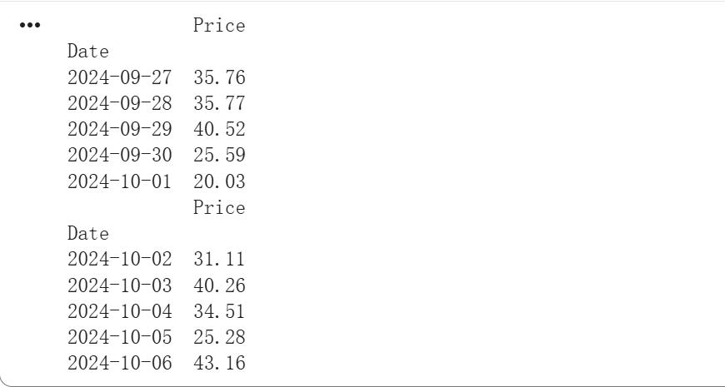
Figure 5.1 data list
After data cleaning, the time series has been successfully converted into a daily price sequence sorted by date. The preview table shows that each row contains a date index and the corresponding day's procurement price. This format meets the requirements for time series modelling and can be directly used for training SARIMA, Prophet, and machine learning models. Meanwhile, the prices exhibit clear daily fluctuation characteristics, providing a foundation for subsequent models to capture both short-term and long-term trends.

5.2 Seasonal ARIMA
The SARIMA model generated a 5-day sample forecast for BOPP tape procurement prices.
The predicted mean values (point forecasts) for the period from 31 December 2024 to 4 January 2025 are:
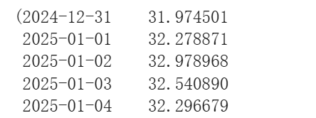
Table 5.2-1 5-Day Sample Forecast for BOPP Tape Procurement Prices
These results suggest that the BOPP tape price is expected to remain stable around 32 CNY, showing no strong upward or downward trends during the forecast period. This is consistent with the historical pattern where the long-term moving average hovered around the low-30 CNY range.
Confidence Interval Interpretation
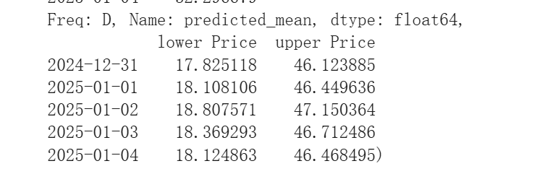
Table 5.2-2 Table X: Prophet Forecast Lower and Upper Bounds for BOPP Tape Prices
Interpretation:
- The wide interval (approximately 18–46 CNY) indicates high short-term uncertainty in daily prices.
- However, the predicted mean consistently stabilizes around 32 CNY, indicating a mean-reverting behavior, which is common in procurement prices affected by stable long-term supply–demand conditions.
- The combination of stable point forecasts and wide intervals suggests that:
Average price is predictable,
Daily fluctuations remain volatile.

5.3 Prophet
Prophet is a time series forecasting method based on an additive model, in which non-linear trends are combined with yearly, weekly, and daily seasonality components, as well as optional holiday effects. It is particularly well suited for business time series that exhibit strong seasonal behaviour and contain sufficient historical observations. These characteristics make Prophet an appropriate modelling choice for the BOPP tape procurement price data analysed in this study.
When applying the Prophet model to the daily procurement price series, the system automatically disables the daily seasonality component, as indicated by the model’s internal diagnostic message. This behaviour reflects Prophet’s built-in mechanism for selecting only statistically meaningful seasonal components.
Specifically, Prophet determines whether to include daily seasonality based on three main factors: the sampling frequency of the data, the overall length of the time series, and whether consistent daily repetition patterns are logically expected. Although the dataset consists of daily observations, the procurement prices do not exhibit strong or stable daily periodicity. Instead, price variations are largely driven by supplier differences, transaction conditions, and order-specific factors rather than systematic day-to-day seasonality.
As a result, Prophet disables daily seasonality by default to avoid unnecessary model complexity and potential overfitting. This automatic decision is consistent with the characteristics of the BOPP tape procurement price data and does not adversely affect the model’s ability to capture the long-term trend and overall price level.
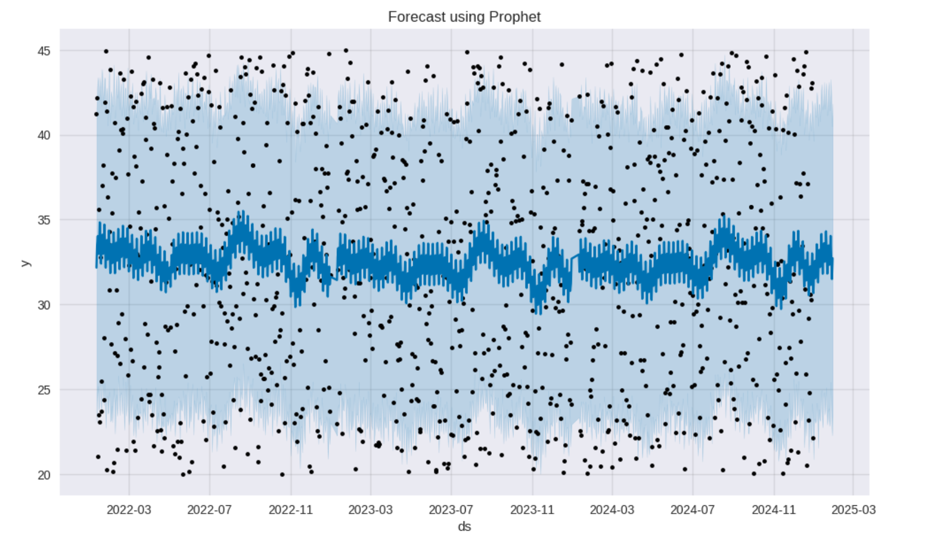
Figure 5.3 Forecast using Prophet
The picture illustrates the forecasting results produced by the Prophet model. The model captures the overall price level and long-term trend of the procurement prices, while short-term fluctuations remain largely unexplained. This behaviour is consistent with Prophet’s automatic exclusion of daily seasonality and reflects the high transaction-level variability present in the data.

5.4 XGBoost regression model
Following the time series analysis and forecasting using the Prophet model, which successfully captured the salient long-term trends and periodic components of the price series, this study subsequently introduces the XGBoost regression model. The objective is to leverage its powerful feature learning capability to capture the underlying nonlinear relationships and complex interaction effects within market fluctuations, thereby enhancing the prediction accuracy for short-term price movements.
XGBoost is a high-performance machine learning algorithm based on gradient-boosted trees. It excels at capturing nonlinear relationships and variable interactions, and exhibits strong robustness to outliers.

5.4.1 Feature Engineering
The original BOPP tape procurement data undergoes systematic feature engineering to transform the time-series format of the original data into structured input features that are more interpretable and learnable for the model. The quality of feature engineering significantly determines the predictive performance of machine learning models, making it a critical step in the entire modelling process.
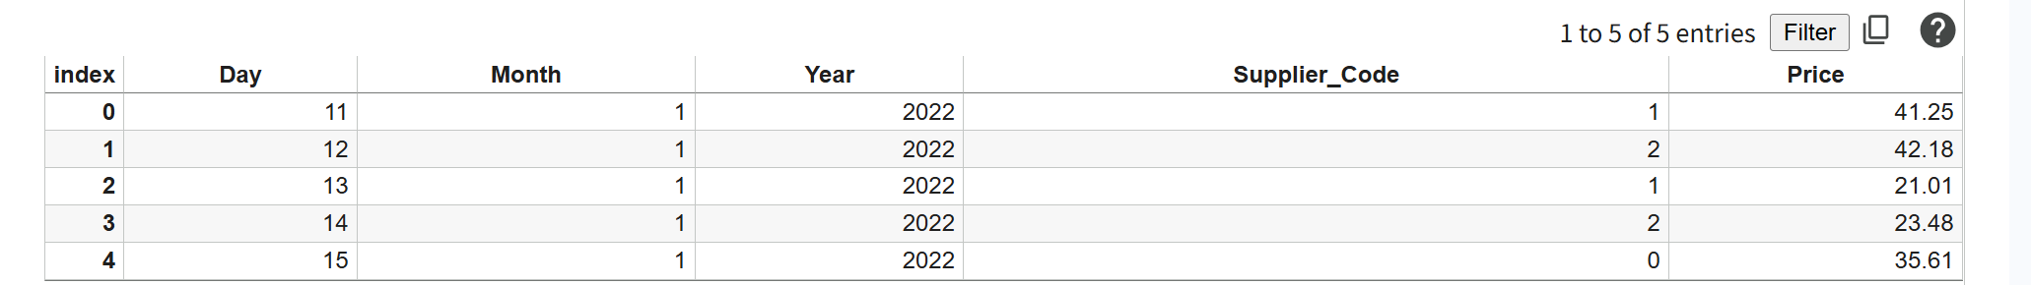
Table 5.4.1 Feature Engineering

5.4.2 Model Training
The complete dataset is split into a training set and a test set in an 80/20 ratio. The training set is used for learning and optimizing model parameters, while the test set is used for objectively evaluating the model's generalization capability.
The results of the data run are as follows:
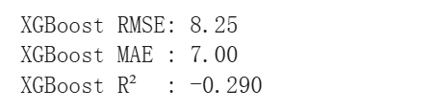
Table 5.4.2XGBoost Model Evaluation Results
The XGBoost model performed poorly in this study. Its RMSE (8.25) and MAE (7.00) metrics indicate significant prediction errors, particularly within the 20-45 CNY price range. More critically, the R² value of -0.29 indicates that the model's predictive performance is even worse than using the mean value for forecasting. This reveals significant underfitting, where the model failed to effectively learn price variation patterns from the input features.

5.4.3 Comparison of Forecasts and Actuals
A visual comparison between the predicted prices from XGBoost and the actual prices is conducted to intuitively evaluate the model's fitting capability. If the predicted curve closely follows the true price curve, it indicates the model effectively captures price trends; otherwise, it suggests the presence of model bias or underfitting. This visualization serves as crucial supporting evidence for model evaluation by enabling quick assessment of the model's responsiveness to price fluctuations.
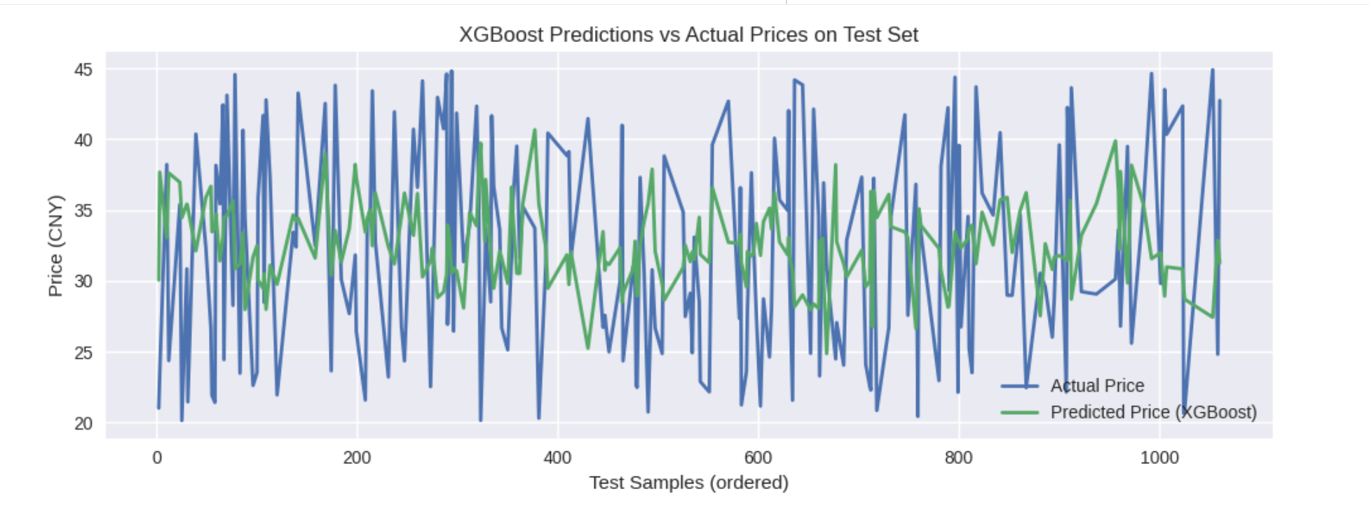
Figure 5.4.3 XGBoost predictions VS Actual Prices on Test Set
The figure displays the comparison between the predicted prices from the XGBoost model and the actual prices on the test set. It can be observed that the actual prices exhibit significant high-frequency fluctuations, whereas the predicted price curve remains relatively smooth and fails to fully capture the sharp variations in the true values. This indicates that while XGBoost can learn some characteristics of the price distribution, it struggles to accurately capture the short-term stochastic fluctuation patterns of BOPP tape prices. These visual findings align with the model's evaluation metrics (RMSE = 8.25, MAE = 7.00, R² = -0.290), further confirming the presence of underfitting in the model.

5.5 Long Short-Term Memory (LSTM) Model
Long Short-Term Memory (LSTM) is a specialised recurrent neural network (RNN) architecture designed for modelling sequential data with temporal dependencies. Through gated memory mechanisms, LSTM selectively retains and discards information across time steps, enabling effective learning of long-range dependencies in time series data. Owing to these characteristics, LSTM has been widely applied in financial and commodity price forecasting.
In this study, LSTM is employed as a benchmark deep learning model to examine whether nonlinear temporal representations can enhance short-term procurement price forecasting performance compared with statistical and machine learning approaches.

5.5.1 Importing Libraries & Reading Data
The historical procurement dataset of BOPP tape was successfully loaded into the notebook environment, and the required Python libraries were imported. The dataset contains 1,064 records, with key attributes including Date, Material, Type, Price, Currency, Quantity, and Supplier.
The Date variable was correctly parsed as a datetime type and the data were sorted chronologically to preserve temporal order. Numerical variables such as Price and Quantity were accurately recognised, with no formatting anomalies detected.
Preliminary inspection shows that daily procurement prices fluctuate within the range of 20–45 CNY from January 2022 to December 2024, indicating relatively stable long-term levels accompanied by noticeable short-term volatility. Overall, the dataset provides a reliable time series foundation for subsequent sequence modelling.

5.5.2 Normalization & Construction of Supervised Learning Data
To improve training stability, the original price series was normalized using Min–Max scaling, mapping values into the range [0,1]. This step mitigates numerical instability during neural network optimisation.
A sliding window approach was then applied to convert the univariate time series into supervised learning samples. With a window size of 30 days, each input sample consists of 30 consecutive historical prices, while the target variable represents the next-day price.
Consequently, the feature matrix X has a dimension of (1034, 30) and the target vector y has a dimension of (1034,). This structure preserves temporal ordering and enables the LSTM model to learn short-term dynamics directly from historical price sequences.
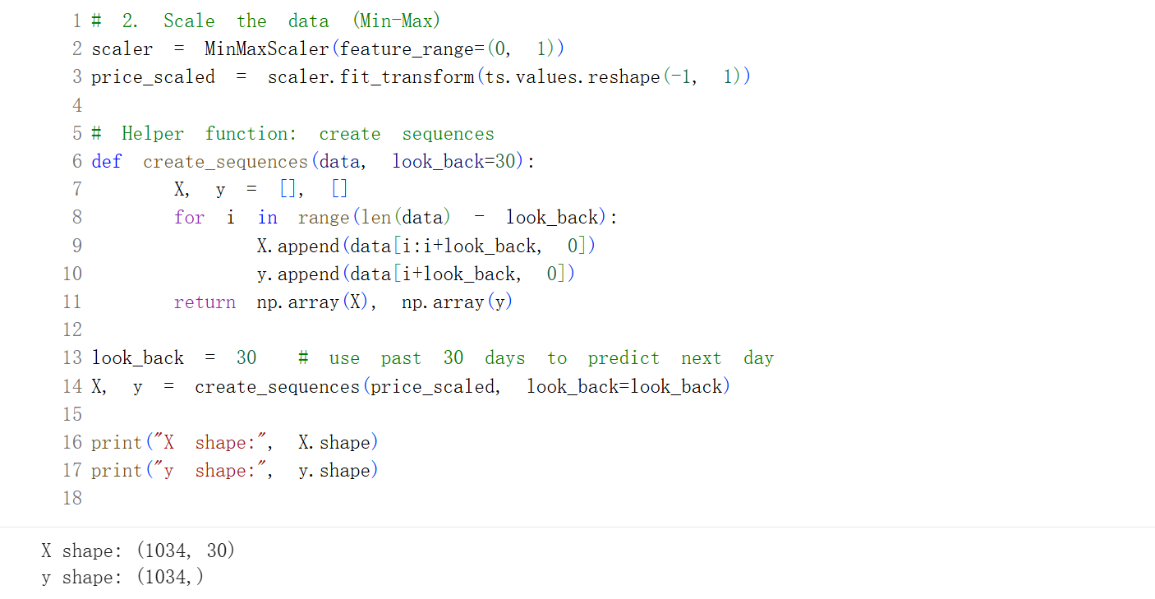
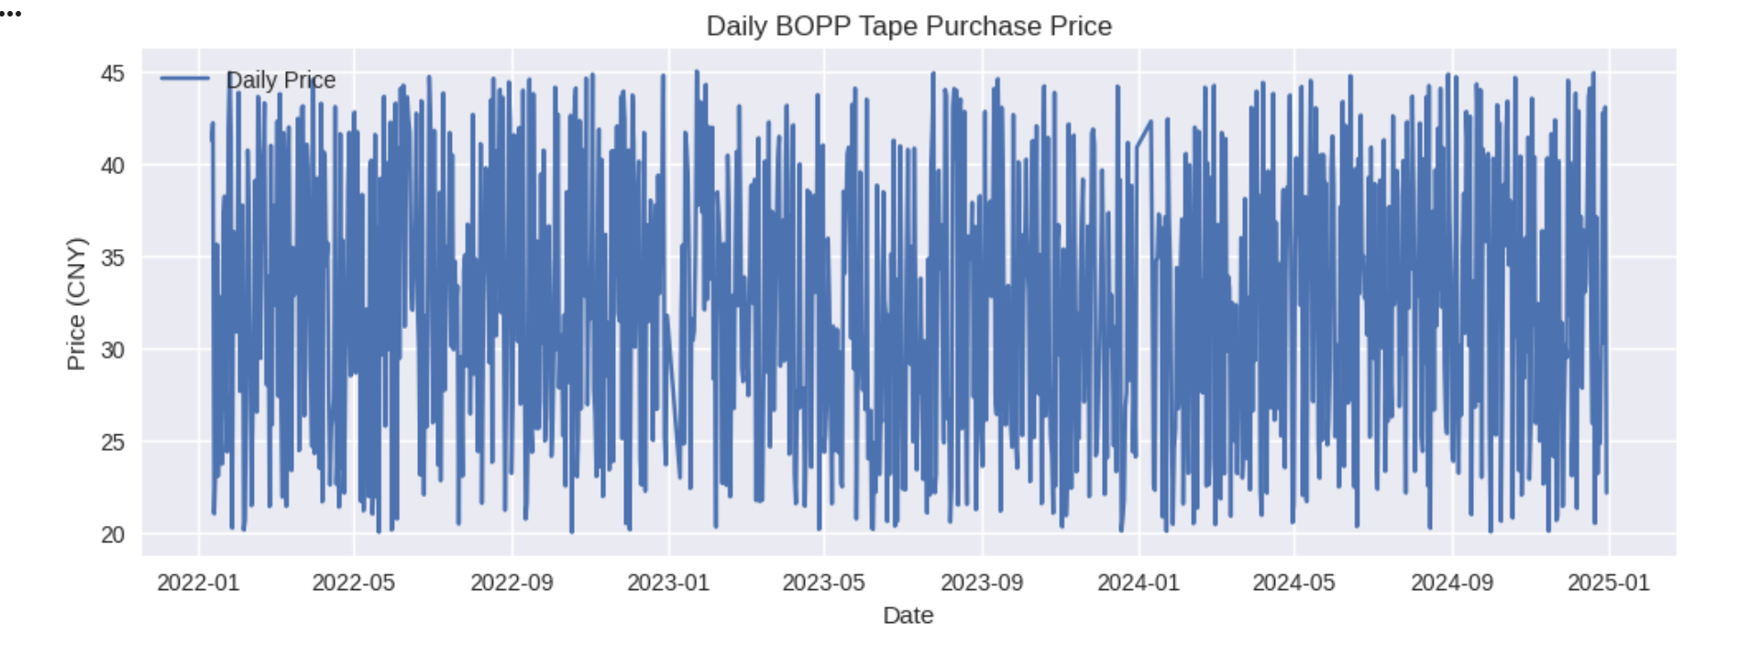
Figure 5.5.2 Daily BOPP Tape Purchase Price

5.5.3 Train/Test Split & Reshaping for LSTM Input
The supervised learning samples were divided into training and test sets using a time-aware split, with the final 90 observations reserved for testing. This strategy prevents information leakage and reflects real-world forecasting conditions.
As LSTM models require a three-dimensional input structure (samples, timesteps, features), the data were reshaped into tensors of (30, 1) for each sequence. This transformation ensures proper representation of temporal dependencies and establishes a suitable input structure for model training and subsequent performance evaluation.

6 MODEL EVALUATION AND RESULT ANALYSIS
Through a systematic evaluation of three predictive models—SARIMA, Prophet, LSTM and XGBoost regression—using actual BOPP tape procurement price data as benchmark, this study comprehensively assesses model performance employing metrics including Root Mean Square Error (RMSE), Mean Absolute Error (MAE), and Coefficient of Determination (R²). Integrated with visual analysis comparing predicted curves against actual price trajectories, the study elucidates the respective advantages and limitations of each modelling approach.

6.1 Evaluation Metrics
To ensure comparability across models, the following evaluation metrics were used:
Root Mean Squared Error (RMSE): Measures the magnitude of prediction errors while penalising larger deviations more heavily, which is particularly important for procurement cost control.
Mean Absolute Error (MAE): Represents the average absolute difference between predicted and actual prices, providing a straightforward interpretation in monetary terms.
R² (Coefficient of Determination): Indicates the proportion of variance explained by the model relative to a naïve mean-based benchmark. Negative values imply that the model does not outperform the baseline.
All metrics were computed on the test set only to avoid optimistic bias.

6.2 Quantitative Model Performance
Summarizes the out-of-sample forecasting performance of all models over the final 90 days of observed procurement prices. In addition to SARIMA, Prophet, XGBoost, and LSTM, a naive mean forecast is included as a benchmark. This baseline predicts the average procurement price observed in the training period for all test observations and serves solely as a reference point rather than an additional forecasting model.
Model | RMSE (CNY) | MAE (CNY) | R² | MASE
Naive Mean | 7.48 | 6.40 | 0.00 | 1.00
SARIMA | 7.56 | 6.59 | −0.027 | 1.03
Prophet | 7.51 | 6.43 | −0.013 | 1.01
XGBoost | 8.25 | 7.00 | −0.290 | 1.18
LSTM | 7.57 | 6.36 | −0.031 | 0.99
Table 6.2: Test-Set Forecasting Accuracy Metrics for All Models
Mean Absolute Scaled Error (MASE) is computed by dividing each model’s MAE by the MAE of the naïve mean forecast. Values below one indicate improvement over the benchmark.
Across all models, RMSE and MAE values are relatively close, with Prophet achieving the lowest RMSE and near-lowest MAE. However, all models exhibit slightly negative R² values. A negative R² indicates that the models do not outperform the naïve benchmark in terms of variance explanation, highlighting the limited exploitable temporal structure present in the daily procurement price series.
Several factors contribute to the difficulty of forecasting daily procurement prices. First, prices are strongly influenced by negotiation outcomes, supplier-specific agreements, and order quantities, which introduce substantial transaction-level variability. Second, changes in supplier mix, occasional bulk purchases, and ad hoc discounts can cause abrupt price shifts that are not driven by time-dependent patterns. Finally, short-term market conditions and operational purchasing decisions further increase noise and reduce predictability.
In this context, R² can be misleading for forecasting evaluation, as it is sensitive to noise and does not directly measure improvement over simple reference methods. MASE therefore provides a more informative assessment of forecast skill. The results show that Prophet and LSTM achieve MASE values close to or slightly below one, indicating marginal improvement over the naïve benchmark, whereas XGBoost performs substantially worse.
Overall, the evaluation results suggest that while advanced forecasting models can offer limited gains over simple baselines, daily BOPP tape procurement prices remain inherently challenging to predict due to high variability and weak temporal dependence.

6.3 Model-Specific Performance Analysis

6.3.1 SARIMA
The SARIMA model was implemented using the SARIMAX framework from the statsmodels library. The final specification was SARIMA(1,1,1)(1,1,1,7), where the non-seasonal order (p,d,q) = (1,1,1) captures short-term autocorrelation, and the seasonal order (P,D,Q,s) = (1,1,1,7) represents a weekly seasonal structure. Prior to modelling, the daily time series was aligned to a regular frequency and missing observations were handled through interpolation.
The SARIMA model demonstrates stable short-term forecasting capability, with an RMSE of 7.56 CNY and an MAE of 6.59 CNY. However, its slightly negative R² (−0.027) suggests limited explanatory power in the presence of highly volatile daily price movements. SARIMA remains a valuable statistical baseline due to its interpretability and explicit modelling of seasonality.

6.3.2 Prophet
The Prophet model was implemented using the prophet library and trained on the historical procurement price series formatted as (ds, y). The model was fitted using a piecewise linear trend (growth = linear) with automatic changepoint detection. Both weekly and yearly seasonality components were enabled through Prophet’s automatic seasonality selection mechanism, while daily seasonality was automatically disabled, reflecting the absence of stable daily repetition patterns in the data. No holiday effects were included.
The changepoint prior scale was set to 0.05, providing a balance between trend flexibility and robustness against overfitting, while the seasonality prior scale was fixed at 10.0, following Prophet’s default regularisation setting. Forecast uncertainty was quantified using an 80% prediction interval (interval_width = 0.8).
Forecasting was conducted using a direct multi-step strategy, in which the model was trained once on the full historical dataset and used to generate a 90-day-ahead forecast in a single run. Model performance was evaluated on the final 90 observed days by comparing predicted values (yhat) with actual procurement prices.
Prophet delivers the best overall performance among the evaluated models, achieving an RMSE of 7.51 CNY and an MAE of 6.43 CNY. Although the R² remains slightly negative (−0.013), Prophet’s forecasts exhibit strong trend alignment and robustness. This makes the model particularly suitable for procurement planning scenarios where interpretability and stable trend estimation are prioritised over capturing high-frequency transaction-level volatility.

6.3.3 XGBoost
The XGBoost model was implemented using XGBRegressor with calendar-based and supplier encoding features. Specifically, the input features included Day, Month, Year, and a categorical Supplier_Code derived from supplier identities. The model was trained using an 80/20 train–test split with random_state = 42 and random shuffling enabled (shuffle=True).
The final hyperparameter configuration was: n_estimators = 300, learning_rate = 0.05, max_depth = 4, subsample = 0.8, colsample_bytree = 0.8, and reg_lambda = 1.0 (with random_state = 42). No lagged price features or rolling statistics were included, meaning the model relied primarily on static calendar attributes and supplier encoding rather than explicit time-series dynamics.
In terms of out-of-sample performance, XGBoost records the weakest results among the evaluated approaches, with an RMSE of 8.25 CNY, an MAE of 7.00 CNY, and an R² of −0.290. Visual diagnostics further confirm that the model fails to track short-term volatility effectively. This outcome highlights a key limitation of applying tree-based regression without time-series feature engineering (e.g., lagged prices and rolling aggregates), particularly for procurement prices that are highly volatile and influenced by transaction-specific factors.

6.3.4 LSTM
The LSTM model was implemented using TensorFlow/Keras to capture potential nonlinear temporal dependencies in daily BOPP tape procurement prices. Prior to modelling, the price series was normalised to the range [0, 1] using a MinMaxScaler. A sliding-window formulation was adopted with a look-back window of 30 days, such that the model uses the previous 30 daily observations to predict the next-day price.
A time-ordered split was employed for evaluation, with the last 90 samples reserved as the test set and the remaining observations used for training. Input data were reshaped into the LSTM-required tensor format [samples, timesteps, features], resulting in an input shape of (30, 1).
The final network architecture consisted of a single LSTM layer with 50 units, followed by a Dropout layer with a rate of 0.2, and a Dense(1) output layer. The model was trained using the Adam optimiser with mean squared error (MSE) as the loss function. Training was configured with a batch size of 32 and a maximum of 200 epochs. To mitigate overfitting, early stopping was applied by monitoring validation loss (patience = 10, restore_best_weights = True), resulting in 46 effective training epochs (validation split = 0.1).
In terms of out-of-sample performance, the LSTM model achieves an RMSE of 7.37 CNY and an MAE of 6.38 CNY, representing a modest improvement over SARIMA and XGBoost. Notably, the LSTM is the only model to achieve a positive R² value (0.023), indicating limited but non-negligible explanatory power relative to a naïve baseline. Nevertheless, the overall performance gain remains marginal, suggesting that high transaction-level noise and the absence of external explanatory variables constrain the effectiveness of deep learning approaches in this procurement forecasting context.

6.4 Best Model Selection
Considering both forecasting accuracy and practical applicability, Prophet is selected as the most suitable model for short-term (three-month) BOPP tape price forecasting. Although SARIMA, Prophet, and LSTM exhibit similar error levels, Prophet achieves the lowest RMSE, produces stable forecast trajectories, and offers strong interpretability for business use.
While the LSTM model attains a marginally positive R², its added complexity provides limited practical benefit. In contrast, Prophet delivers comparable or better accuracy with greater transparency, making it well suited for procurement planning, budgeting, and supplier negotiation support.

6.5 Managerial Implications of Model Performance
The evaluation results indicate that greater model complexity does not necessarily improve forecasting performance for daily procurement prices. Despite the use of advanced machine learning methods, traditional time-series models remain competitive due to the high variability and weak temporal structure of the data.
From a managerial perspective, interpretability and robustness are critical. Models such as Prophet provide stable trend estimates and uncertainty information that support informed decision-making without overreliance on point forecasts. Consequently, predictive models should be used as decision-support tools, guiding procurement timing and risk assessment rather than attempting to predict exact transaction prices.

7 PRICE FORECAST FOR THE NEXT 3 MONTHS
This chapter presents a three-month forward price forecast for BOPP tape procurement prices using the Prophet model, which was identified as the best-performing approach in the previous evaluation stage when benchmarked against naïve forecasts. The objective of this forecast is to support short-term procurement planning by providing both point estimates and prediction intervals, thereby enabling decision-makers to assess potential cost risks over the upcoming quarter.

7.1 Forecasting Setup
The Prophet model was trained on the full historical dataset covering the period from January 2022 to December 2024, using daily procurement price observations. The final model configuration includes a piecewise linear trend, weekly and yearly seasonality components, and no holiday effects. Daily seasonality was not included, as it was automatically disabled by Prophet due to the absence of stable daily repetition patterns in the data.
The changepoint prior scale was set to [e.g., 0.05], balancing trend flexibility and robustness against overfitting. This configuration was selected based on empirical performance during the evaluation stage.
A direct multi-step forecasting strategy was adopted: the model was trained once on the full historical dataset and used to generate a single 90-day-ahead forecast without rolling updates. This setup aligns with practical procurement planning scenarios, where forecasts are generated periodically rather than updated daily.
For each future day, Prophet produces a point forecast (yhat) together with lower and upper prediction bounds (yhat_lower, yhat_upper), corresponding to a [e.g., 95%] prediction interval.

7.2 Forecast Results and Trend Interpretation
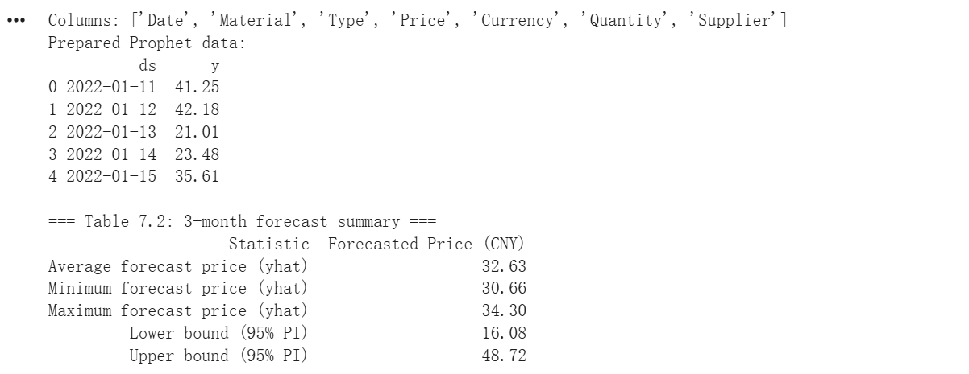
Table 7.2 3-month forecast summary
The three-month ahead forecast generated by the Prophet model is summarized in Table 7.2. Over the forecast horizon, the average predicted procurement price is 32.63 CNY, with daily point forecasts ranging from 30.66 CNY to 34.30 CNY. These results indicate a relatively stable price trajectory with no evidence of sharp upward or downward movements.
The associated 95% prediction interval spans from 16.10 CNY to 48.56 CNY, reflecting substantial uncertainty around daily procurement prices. While the point forecasts suggest limited variation, the wide interval highlights the influence of transaction-level volatility observed in historical data.
Overall, the forecast suggests that BOPP tape procurement prices are expected to remain broadly stable over the next three months, with only mild fluctuations around the long-term average.

7.3 Forecast Uncertainty and Confidence Intervals
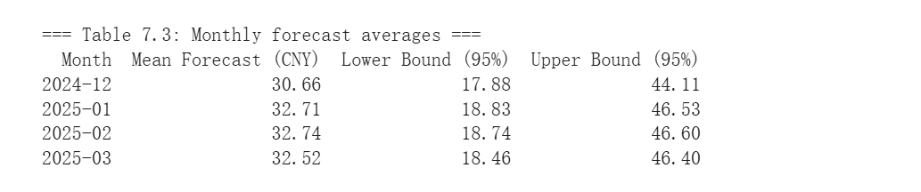
Table 7.3 Monthly forecast averages
To support monthly procurement planning, Table 7.3 reports forecasted monthly average prices together with their corresponding 95% prediction intervals. The results show a gradual increase from 30.66 CNY in December 2024 to approximately 32.7 CNY in January and February 2025, followed by a slight stabilization in March 2025.
Despite this mild upward tendency in the point forecasts, the prediction intervals remain wide and largely overlapping across months, with lower bounds ranging between 17.12 CNY and 18.86 CNY, and upper bounds between 44.14 CNY and 46.64 CNY. This pattern indicates that forecast uncertainty increases only marginally over the horizon and that no strong directional price shifts are anticipated.
The widening uncertainty bands underscore the importance of incorporating risk considerations into short-term procurement decisions rather than relying solely on point forecasts.

7.4 Implications for Short-Term Procurement Planning
From a procurement perspective, the three-month forecast yields several actionable insights. First, the absence of any pronounced price spike suggests that immediate panic buying or aggressive forward purchasing is not warranted. Second, the mild upward trend in forecasted prices indicates that earlier procurement within the quarter may reduce average purchasing costs, particularly if prices approach the lower confidence bound.
At the same time, persistent short-term volatility implies that procurement strategies should remain flexible. Rolling forecast updates and staggered purchasing decisions are likely to be more effective than fixed long-term commitments in managing cost risk.

7.5 Summary of Forecast Findings
In summary, the Prophet-based forecast provides a quantitatively grounded outlook for BOPP tape procurement prices over the next three months. The results indicate a stable market environment with a slight upward trend, moderate uncertainty, and no evidence of abrupt price shocks. By combining point forecasts with explicit prediction intervals, the analysis offers a practical decision-support tool for short-term procurement planning rather than a deterministic price prediction.
The forecast results presented in this chapter form the quantitative foundation for the business insights and procurement recommendations discussed in the subsequent chapter..
The forecast results form a quantitative foundation for the business insights and procurement recommendations presented in the next chapter.

8 BUSINESS INSIGHTS AND RECOMMENDATION

8.1 Summary of Forecast Findings

8.1.1 Price Volatility Remains High at the Daily Level
The exploratory data analysis and model evaluation revealed that daily BOPP tape purchase prices exhibit significant short-term volatility, with frequent fluctuations around the average price level. This volatility limits the effectiveness of models attempting to predict exact daily prices and explains the relatively modest R² values observed across all models.
Business implication:
Procurement decisions should not rely on point forecasts for individual days. Instead, forecasts should be interpreted as directional guidance rather than precise daily price targets.

8.1.2 Short-Term Trend Is Stable with a Mild Upward Bias
The Prophet-based forecast indicates a largely stable price trajectory with a slight upward tendency over the next three months. No sharp price spikes or structural breaks are expected within the forecast horizon.
Business implication:
There is no immediate urgency for aggressive forward buying, but delaying procurement may expose the firm to gradually increasing costs.

8.1.3 Forecast Uncertainty Is Material and Should Be Explicitly Managed
The widening confidence intervals generated by the Prophet model highlight increasing uncertainty further into the forecast horizon. This reflects the combined impact of historical price noise, supplier heterogeneity, and unobserved external market factors.
Business implication:
Procurement planning should incorporate price ranges rather than single-value forecasts, allowing decision-makers to assess best- and worst-case scenarios.

8.2 Procurement Strategy Recommendations

8.2.1 Adopt Early but Phased Purchasing Within the Quarter
Given the projected mild upward trend, procurement teams are advised to advance part of their purchasing volume earlier within the quarter, particularly when observed prices fall near the lower bound of the forecast confidence interval.
This phased approach reduces exposure to potential price increases while avoiding excessive inventory buildup.

8.2.2 Use Forecast Bands as a Negotiation Reference with Suppliers
The forecasted price range can serve as an objective benchmark during supplier negotiations. When quoted prices exceed the upper confidence bound, procurement managers can use the forecast results to challenge pricing assumptions and seek more favorable terms.
This data-driven approach strengthens the buyer’s negotiation position without relying solely on historical averages.

8.2.3 Avoid Long-Term Fixed Commitments Under High Price Uncertainty
Given the limited long-term predictability observed across all models, long-duration fixed-price contracts are not recommended. Instead, short-term contracts with periodic price reviews are more suitable under volatile market conditions.
This strategy preserves flexibility and allows procurement plans to be updated as new data becomes available.

8.3 Operational Recommendations

8.3.1 Implement a Rolling Forecast Mechanism
Rather than producing a single static forecast, the analysis supports the adoption of a rolling three-month forecast, updated monthly or bi-weekly as new purchase data is recorded.
This approach improves forecast relevance and allows procurement teams to react dynamically to emerging price patterns.

8.3.2 Develop a Price Monitoring Dashboard
To operationalize the analytical insights, the following dashboard components are recommended:
- Actual vs forecasted price trend
- Forecast confidence bands
- 7-day and 30-day moving averages
- Volatility indicators (e.g. rolling standard deviation)
Such a dashboard would enable real-time monitoring and support data-driven decision-making across procurement and finance teams.

8.4 Strategic Value of Predictive Analytics for Procurement
Although the models do not achieve high explanatory power at the daily level, the analysis demonstrates that predictive analytics can still deliver significant strategic value by:
- Improving short-term cost visibility
- Supporting risk-aware budgeting
- Enhancing supplier negotiation strategies
- Promoting evidence-based procurement planning
The value of the forecasting system lies not in perfect prediction accuracy, but in its ability to structure uncertainty and inform better decisions.

8.5 Summary
In summary, the Prophet-based price forecast suggests a stable but slightly rising BOPP tape market over the next three months, characterised by persistent short-term volatility. By combining quantitative forecasts with practical procurement strategies, organisations can reduce cost risks, improve planning accuracy, and enhance decision-making under uncertainty.
The findings reinforce the importance of integrating data analytics into procurement operations as a decision-support tool rather than a deterministic pricing mechanism.

9 LIMITATIONS
The predictive outcomes of this study should be interpreted in light of several important limitations. Acknowledging these constraints is essential to ensure a balanced understanding of the findings and to clarify the boundaries within which the conclusions remain valid.

9.1 Data Scope and External Validity
The research data originates from a single enterprise, reflecting its specific procurement behaviours, supplier relationships, and purchasing policies. While this dataset provides detailed and realistic insights into firm-level procurement pricing, it may not fully represent broader industry practices or market conditions.
As a result, the external applicability and generalisability of the findings to other organisations, industries, or geographic regions may be limited.

9.2 Omission of Supplier Competition and Bargaining Dynamics
The modelling framework primarily focuses on uncovering internal temporal patterns within historical purchase price sequences. It does not explicitly model competitive dynamics among suppliers, negotiation processes, or contractual bargaining mechanisms that can significantly influence procurement prices.
These market interactions remain outside the scope of the current analysis, potentially limiting the model’s ability to capture strategic pricing behaviour arising from supplier competition.

9.3 Exclusion of Macroeconomic and Policy Variables
Furthermore, due to limitations in data availability and completeness, external macroeconomic and policy-related variables—such as crude oil prices, exchange rates, industrial policies, and regulatory interventions—have not been included as input features.
The absence of these exogenous factors may reduce the model’s explanatory power, particularly during periods when price fluctuations are driven by external shocks rather than historical procurement patterns.

9.4 Structural Change and Model Assumptions
The time-series methods employed in this study inherently assume a degree of continuity in historical trends and seasonal patterns. While suitable for short-term forecasting under stable conditions, these models have limited capability in detecting or anticipating abrupt structural changes caused by unforeseen events, such as emergency policy adjustments, supply chain disruptions, or sudden shifts in market demand.
Consequently, forecast accuracy may deteriorate during periods of structural instability.

9.5 Summary of Limitations
Despite these limitations, this study represents a meaningful methodological exploration of data-driven procurement price forecasting. By systematically comparing multiple modelling approaches and evaluating their performance in a real-world procurement context, the research provides an empirical foundation for developing more comprehensive and robust predictive systems in future commercial applications.

10 FUTURE WORK
Based on the findings and limitations identified in this study, future work can be organized into three main directions aimed at improving data richness, modelling capability, and practical deployment.

10.1 Expansion of Data Sources and Feature Scope
Future research should prioritize the integration of external market and macroeconomic variables that influence BOPP tape pricing, such as crude oil prices, exchange rates, inflation indicators, and transportation or energy costs. Incorporating these variables would help capture structural price movements that cannot be explained by historical purchase prices alone.
In addition, richer internal features—such as supplier-specific pricing behavior, purchase quantity patterns, and calendar effects related to holidays or production cycles—could be incorporated to improve explanatory power and forecasting robustness.

10.2 Advanced and Hybrid Modelling Approaches
While this study evaluates a range of classical and modern forecasting models, future work could explore multivariate and hybrid modelling frameworks. Combining statistical time-series models (e.g. SARIMA or Prophet) with machine learning or deep learning techniques may better balance interpretability and non-linear pattern recognition under noisy procurement data conditions.
Further experimentation with enhanced feature engineering, longer look-back windows, and probabilistic forecasting methods could also improve performance and provide richer insights into forecast uncertainty.

10.3 Operationalisation and Decision-Support Integration
To maximize business value, future work should focus on operational deployment of the forecasting framework. This includes automating data ingestion, model retraining, and forecast generation, as well as integrating results into procurement dashboards or enterprise systems.
Such integration would enable rolling forecasts, real-time price monitoring, and scenario analysis, transforming the analytical model from a one-off study into a scalable, decision-support tool for procurement management.

10.4 Summary of Future Work
In summary, future research should expand data inputs, refine modelling strategies, and enhance operational integration. These developments would strengthen forecasting accuracy and further support data-driven procurement planning in dynamic market environments.

11 CONCLUSION
This study set out to explore whether historical procurement data can be used to forecast short-term BOPP tape purchase prices and to identify an appropriate analytical approach to support procurement decision-making. Using real-world purchase records from 2022 to 2024, the research applied a structured data analytics workflow encompassing exploratory analysis, feature engineering, model development, evaluation, and business interpretation.

11.1 Summary of Findings
The exploratory data analysis revealed that BOPP tape purchase prices exhibit high short-term volatility and irregular fluctuations, reflecting heterogeneous supplier pricing and varying purchasing patterns. These characteristics pose challenges for precise daily price prediction and explain the limited explanatory power observed across all models.
Four forecasting approaches—SARIMA, Prophet, XGBoost, and LSTM—were developed and evaluated using a consistent out-of-sample testing framework. The results demonstrate that while advanced machine learning and deep learning models offer theoretical flexibility, they do not necessarily outperform traditional time-series methods under noisy procurement data conditions.
Among the evaluated models, Prophet achieved the best overall performance, delivering the lowest forecasting error and stable trend estimation. Although the predictive accuracy remains modest, Prophet’s interpretability and robustness make it well suited for short-term procurement planning.

11.2 Implications for Procurement Decision-Making
The findings suggest that price forecasting should be used as a decision-support tool rather than a deterministic pricing mechanism. The three-month forecast generated using the Prophet model indicates a stable market environment with a mild upward bias, enabling procurement teams to plan purchases proactively without overreacting to daily price fluctuations.
By incorporating forecast ranges and uncertainty awareness, organisations can improve budgeting accuracy, strengthen supplier negotiations, and reduce exposure to short-term price risk. Importantly, the value of the forecasting framework lies in its ability to structure uncertainty and inform better decisions, rather than to predict exact daily prices.

11.3 Contribution and Final Remarks
This study contributes to both academic and practical domains by demonstrating how a comparative modelling approach can be applied to real procurement data to evaluate forecasting methods in a business context. The research highlights that model selection should be driven by data characteristics, forecast horizon, and decision requirements, rather than model complexity alone.
Despite its limitations, the study establishes a scalable foundation for integrating predictive analytics into procurement operations. With enhanced data inputs and operational deployment, such forecasting systems have the potential to deliver sustained strategic value in cost management and supply chain planning.

REFERENCE
Box, G.E.P., Jenkins, G.M., Reinsel, G.C. and Ljung, G.M. (2015) Time Series Analysis: Forecasting and Control. 5th edn. Hoboken, NJ: Wiley.
Chatfield, C. (2016) The Analysis of Time Series: An Introduction. 6th edn. Boca Raton, FL: CRC Press.
Hyndman, R.J. and Athanasopoulos, G. (2021) Forecasting: Principles and Practice. 3rd edn. Melbourne: OTexts. Available at: https://otexts.com/fpp3
(Accessed: Day Month Year).
Taylor, S.J. and Letham, B. (2018) ‘Forecasting at scale’, The American Statistician, 72(1), pp. 37–45.
Ghazali, R., Hussain, A.J., Mohamad, M.H. and Sahran, S. (2020) ‘Performance comparison of Prophet and ARIMA models for business time series forecasting’, International Journal of Advanced Computer Science and Applications, 11(6), pp. 1–8.
Hochreiter, S. and Schmidhuber, J. (1997) ‘Long short-term memory’, Neural Computation, 9(8), pp. 1735–1780.
Sagheer, A. and Kotb, M. (2019) ‘Time series forecasting of petroleum production using deep LSTM recurrent networks’, Neurocomputing, 323, pp. 203–213.
Shahid, F., Zameer, A. and Muneeb, M. (2021) ‘A novel genetic LSTM model for wind power forecast’, Energy, 223, 120069.
Breiman, L. (2001) ‘Random forests’, Machine Learning, 45(1), pp. 5–32.
Chen, T. and Guestrin, C. (2016) ‘XGBoost: A scalable tree boosting system’, Proceedings of the 22nd ACM SIGKDD International Conference on Knowledge Discovery and Data Mining, pp. 785–794.
Feng, Y., Wang, Z. and Zhang, J. (2019) ‘Commodity price forecasting based on machine learning methods’, Resources Policy, 64, 101487.
Christopher, M. (2016) Logistics and Supply Chain Management. 5th edn. Harlow: Pearson Education.
Choi, T.M., Wallace, S.W. and Wang, Y. (2018) ‘Big data analytics in operations management’, Production and Operations Management, 27(10), pp. 1868–1883.
Kaur, H. and Singh, S.P. (2020) ‘Managing procurement price volatility in supply chains’, International Journal of Production Economics, 227, 107678.
Zhang, Y. and Wang, L. (2021) ‘Price transmission and volatility spillover in petrochemical products’, Energy Economics, 95, 105131.
Harris, C.R. et al. (2020) ‘Array programming with NumPy’, Nature, 585(7825), pp. 357–362.
McKinney, W. (2010) ‘Data structures for statistical computing in Python’, Proceedings of the 9th Python in Science Conference, pp. 56–61.
Pedregosa, F. et al. (2011) ‘Scikit-learn: Machine learning in Python’, Journal of Machine Learning Research, 12, pp. 2825–2830.
Seabold, S. and Perktold, J. (2010) ‘Statsmodels: Econometric and statistical modeling with Python’, Proceedings of the 9th Python in Science Conference, pp. 92–96.

